

**ECEN 5053-003 Homework Assignment**

Course Name: Embedding Sensors and Actuators

Corresponding Module: C1M3

Week Number: 3

Module Name: Flow Sensors

Submitted by: Poorn Mehta

**Problem A**: You want to measure the flow rate of air of density 1.225 kg/m3 in a differential pressure meter. The upstream pressure is 20 N / m2 and the downstream pressure is 15 N / m2. The meter has an area of 0.1 m2. What is the flow rate in m3 / sec?

Solution: **0.286 m3/s**

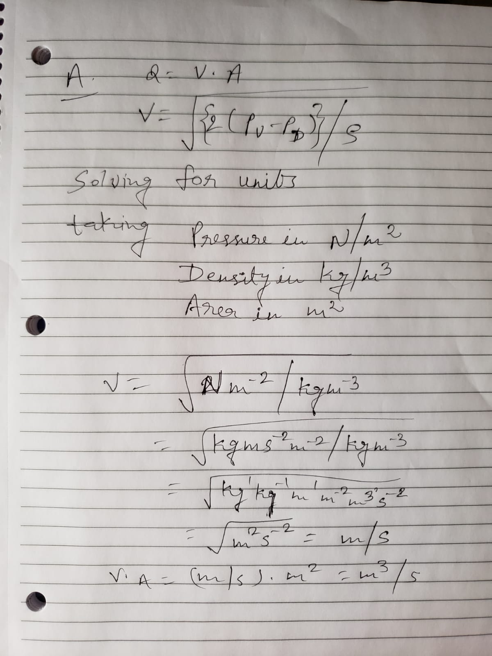

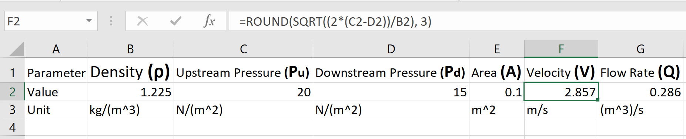

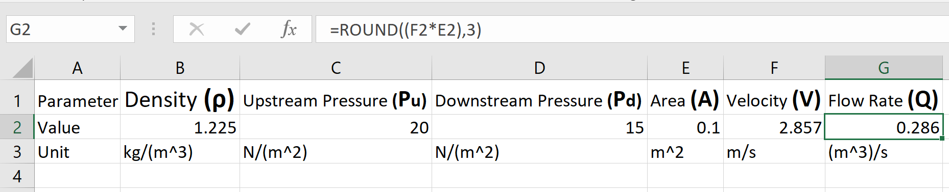

As per shown above, first all the parameters are verified to be in standard SI units, and calculation is done to get the final answer in the required units. Then, excel is use to implement equations, plug in the values and get the answer. The equation is taken from the slides provided by Prof. Mendelson.

**Problem B**: What advantage does a coriolis meter have over a thermal mass flow meter when measuring the mass flow rate of a gas?

Solution: Coriolis flow meter has many advantages over a thermal mass flow meter, while the application is to measure the mass flow rate of a gas. Key ones are as per the following.

**Accuracy** – Coriolis flow meters are known to have way better accuracy than thermal mass flow meters [**[1]**](https://www.flowcontrolnetwork.com/coriolis-thermal/). Typically, a Coriolis flow meter has a accuracy of 0.25% of flow rate for gas [**[2 – page 4]**](https://www.emerson.com/documents/automation/product-data-sheet-elite-series-coriolis-flow-density-meters-en-66748.pdf) while a thermal mass flow meter only has the accuracy of 1% at best for gas [**[3]**](http://www.onicon.com/pdfs/F-5500-Catalog-Sheet.pdf) .

**Additional Requirement** – In order for thermal mass flow meter to work for gases, the composition of the specific gas flowing through has to be known[**[4]**](https://www.flowcontrolnetwork.com/part-i-pros-cons-of-gas-flowmeters/). No such data is required for Coriolis flow meter.

**Higher Flow Rate** – Coriolis flow meters are having support for higher flow rates than the thermal mass flow meters. For example, comparing in SCFM (Standard Cubic Feet per Minute), the Coriolis flow meters are supporting the flow rates up to 320,000 SCFM [**[5 – page 8]**](https://www.emerson.com/documents/automation/product-data-sheet-elite-series-coriolis-flow-density-meters-en-66748.pdf) , while the thermal mass flow meters are having the maximum flow rate of 109,900 SCFM (35,000 SFPM * cross sectional area of pipe with 24inch diameter) [**[6 – page 1,2]**](http://www.onicon.com/pdfs/F-5500-Catalog-Sheet.pdf).

**Higher Process Temp** – Coriolis flow meters are supporting much higher process temperature than the thermal mass flow meters. For example, a Coriolis flow meter can support 662°F[**[7 – page 15]**](https://www.emerson.com/documents/automation/product-data-sheet-elite-series-coriolis-flow-density-meters-en-66748.pdf) while a thermal mass flow meter can’t operate for more than 250°F [**[8]**](http://www.onicon.com/pdfs/F-5500-Catalog-Sheet.pdf) .

**Higher Pressure** – Coriolis flow meters are also supporting very high process pressures, when compared to thermal mass flow meters. For example, a Coriolis flow meter can work up to 414 barg [**[9 – page 11]**](https://www.emerson.com/documents/automation/product-data-sheet-elite-series-coriolis-flow-density-meters-en-66748.pdf) , while a thermal mass flow meter can only support up to 20.7 barg [**[10]**](http://www.onicon.com/pdfs/F-5500-Catalog-Sheet.pdf) .

**Problem C**: You want to measure the flow rate of a gas at roughly 400°C, 15 Bar static pressure, and 150 m/s flow velocity. Which is the only type of flow meter, from the 7 types that we discussed in class, that you can use *and why?*

Solution: **Differential Pressure Flow Meter**

The given temperature is very high, and out of range for almost all type of flow meters except the differential pressure flow meter. Also, the flow velocity is high, when the temperature itself is so high. Taking as an example. Rosemount 3051SFC Differential Pressure Flow Meter is capable to work with given conditions. It’s remote version can work up to 454°C [**[11 – page 41]**](https://www.emerson.com/documents/automation/product-data-sheet-rosemount-dp-flowmeters-primary-elements-en-87598.pdf), while being able to handle the pressure of massive 250,000 bar [**[12 – page 18]**](https://www.emerson.com/documents/automation/product-data-sheet-rosemount-dp-flowmeters-primary-elements-en-87598.pdf) , which is way higher than the required 15 bar amount.

While there are a few flow meters which are not of differential pressure type, which can almost work up to the temperature range of 400°C, such as a thermal mass flow sensor which can work at 400°C [**[13]**](https://www.ist-ag.com/sites/default/files/DFFS74W_E.pdf) , but can’t handle more than 100m/s in velocity. A Coriolis flow sensor can go up to 350°C, but that’s not enough for the presented use case [**[14 – page 15]**](https://www.emerson.com/documents/automation/product-data-sheet-elite-series-coriolis-flow-density-meters-en-66748.pdf).

Looking at the other flow meters, majority of them need to include something complex inside the flow itself. And this causes operating them for a long time, very difficult. Variable Area, Vortex, Turbine, are therefore unsuitable for the use case – as obviously it would be hard to develop internal parts from material that works flawlessly at such high temperature and velocity. While differential pressure flow meter also needs a constriction to be included inside the pipe, it is a much simpler arrangement than the others. Ultrasonic sensors additionally, can’t work with gases as they don’t have large enough particles to cause the frequency shift and to create the doppler effect.

**Problem D**: What are *three* differences in the method and principal of operation between a variable area meter and a differential pressure flow meter? (note: this question is not asking about the specifications of the meters)

Solution:

1. Variable area meter simply uses the fact that as the flow rate of a fluid increases, the acting force upon a submerged object increase in the direction of the flow; while differential pressure flow meter makes use of Bernoulli’s equation, by introducing a constriction in the flow.
2. Variable area meter works relatively at constant pressure [**[15]**](https://www.omega.co.uk/literature/transactions/volume4/variable-area-flow.html), while as the name suggests itself, differential pressure flow meter works on the basis of difference of the pressure drop between two point – before and after constriction.
3. Variable area meter needs to keep a float or some similar structure, completely submerged in the pipe all the time, and it’s the primary mechanism of the flow meter so – it is tightly coupled to the installation location. However, differential pressure flow meter’s primary mechanism sits outside on the pipe, while just a small part of it – constriction creator sits inside the pipe.
4. The output of the variable area meter has to be read manually by means of visual inspection while, the output of differential pressure flow meter can be transmitted electrically to remote locations.
5. Variable area meter works with a single direction flow and pressure, while differential area meter works with two differently directed flow directions and pressure drops.

References for Differential Pressure Flow Meter –[**[16]**](http://www.flowmeters.com/differential-pressure-technology)[**[17]**](https://www.omega.com/literature/transactions/volume4/T9904-07-DIFF.html)

**Problem E**: The k-factor for a turbine meter for flow in a 1.5” (38.1 mm) diameter pipe is 110 pulses per liter. Your magnetic pickup assembly recorded a frequency of 150 Hz. What is the flow rate Q in liters per minute?

Solution: **81.82 liters/minute**

K factor for a turbine meter is the number of pulses the turbine meter generates per the given unit of volume passing through the pipe [**[18]**](http://www.sponsler.com/kfactor.htm). It makes the calculations very simple, and free of the size of the pipe. In the given situation, the pulses being generated are 150 per second. And the K factor has the value 110 pulses per liter passing through the turbine meter. Therefore in a minute, there will be (number of pulses * 60) / K factor; would be flowing through. This will give us the equation – (150 * 60) / 110 = 81.82 liters per minute.

**Problem F**: A Coriolis flow meter has a liquid flow accuracy of 0.25% of flow rate and a zero stability of 3.5 kg / hr. What is the maximum error in kg /hr in the flow rate reading when the meter measures a flow rate of 2500 kg / hr?

Solution: **6.236 kg/hr**

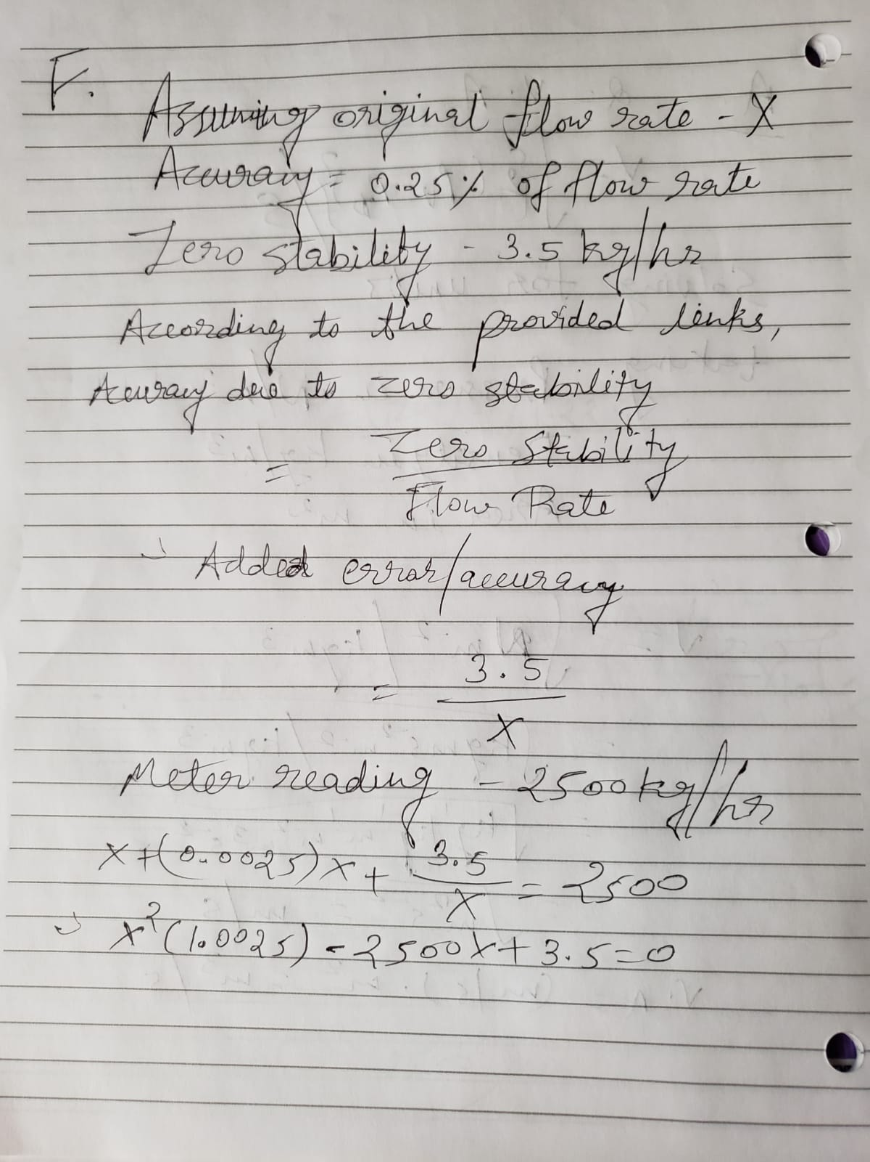 First there is a need to calculate the error which results from the zero stability of the Coriolis flow meter. The zero stability can be interpreted as – how well the zero of the Coriolis flow meter can be adjusted. In the typical automated process, the meter is filled with the water with absolutely no flow, and the error is measured [**[19]**](https://www.flowcontrolnetwork.com/coriolis-mass-flow-meter-zero-stability/) . It can be said that the zero stability is the measure of the flow meter’s sensitivity, and is determined by the manufacturer. The effect of zero stability on the meter accuracy is higher at lower flow rates [**[20]**](https://www.flowcontrolnetwork.com/coriolis-mass-flow-meter-zero-stability/) , as it is the ratio of zero stability value to the mass flow rate [**[21 – page 5]**](https://www.emerson.com/documents/automation/-direct-approach-to-mass-flow-measurement-en-64236.pdf)[**[22 – page 4]**](https://www.emerson.com/documents/automation/coriolis-mass-flow-meters-for-natural-gas-measurement-en-65634.doc) . This will result in the following formulae and calculations.

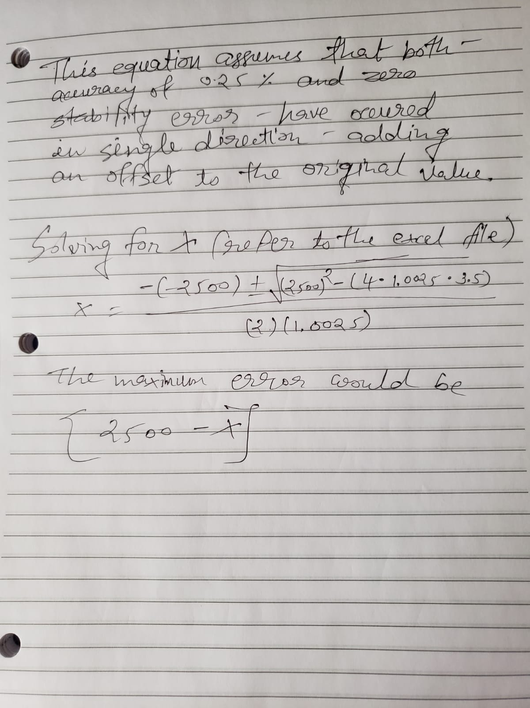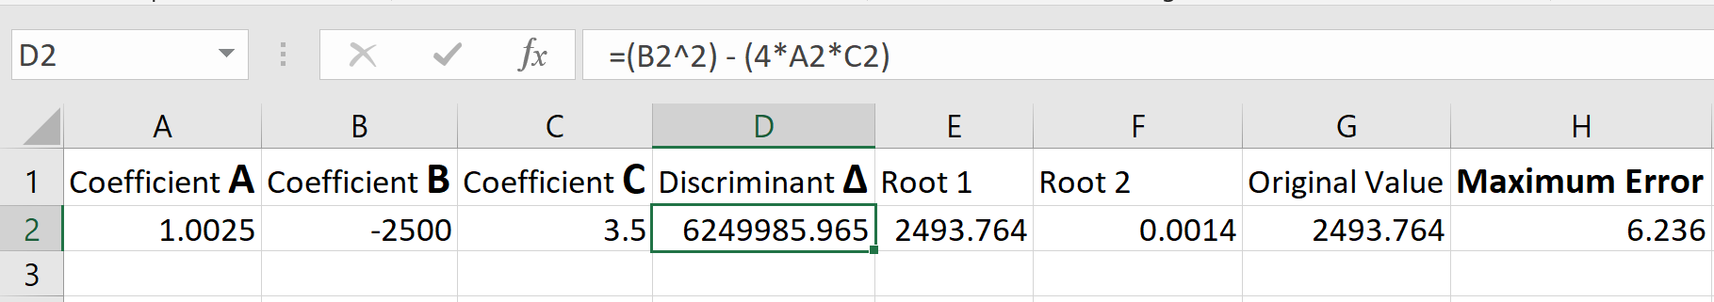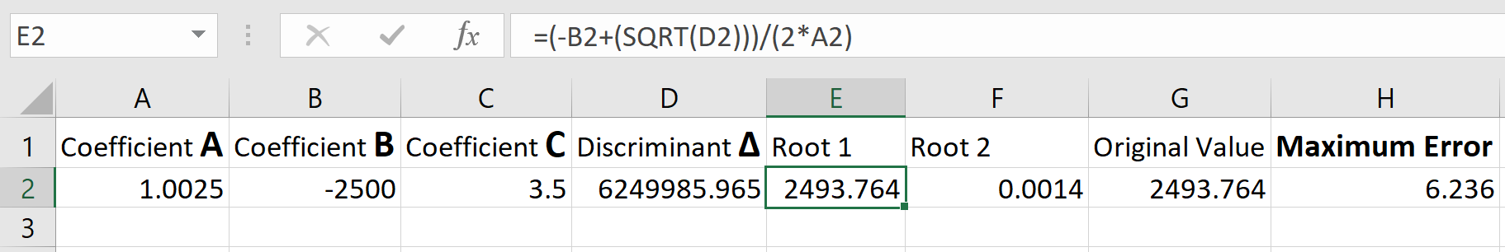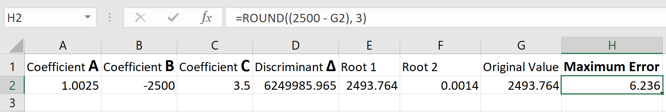

**Problem G**: What are *three* differences in the pattern of fluid flow between laminar flow and turbulent flow?

Solution:

1. Laminar flow is a streamlined flow, lacking any swirls or cross currents; while the Turbulent flow is an irregular flow, having whirlpools and similar things.
2. In Laminar flow, every particle of a fluid flows along one smooth path. The particles of the fluid do not interfere with one another, they don’t mix or shift between layers; however in Turbulent flow, particles can move back and forth between layers, mixing and falling into different patterns.
3. The cylindrical layers in Laminar flow, move at different speeds. The outermost being the slowest and the inner most being the fastest. Also, the laminar flows generally have quite low speeds in average. On the other hand, Turbulent flow have almost identical speed along various layers, because there is no clear distinction or boundary between layers, as the Lamniar flow. Also, Turbulent flows generally have quite high speed of movement.
4. Generally, Laminar flow takes place in pipes because there’s no space for particles to move freely; and Turbulent flow takes place where there is more than enough space for the liquid particles to be, while flowing.
5. Laminar flows have Reynold’s number less than 2300, while the Turbulent flows have Reynold’s number more than 4000.

Reference: [**[23]**](https://sciencetrends.com/the-difference-between-laminar-and-turbulent-flow/)

**Problem H**: How is a vortex created in the middle of pipe when using a vortex meter? How does the vortex meter measure the flow rate?

Solution:

According to Von Karman effect, when a non-streamlined object (also known as the bluff body) is placed in the path of a fast flowing stream, it causes the fluid to alternatively separate from the object on its two downstream sides, and, as the boundary layer becomes detached and curls back on itself, it ends up forming vortices (also called whirlpools or eddies).

The Von Karman effect also notes that, the vortices created due to the bluff body have a constant distance from each other, and it is dependent solely on the size of the bluff body, which formed them.

On the side of the bluff body where the vortex is being formed, the fluid velocity is higher and the pressure is lower. As the vortex moves downstream, it grows in strength and size, and eventually detaches or shreds itself. This is followed by the vortex being formed on the other side as well. The altering vortices are spaced at equal distances.

The majority of vortex meters uses piezoelectric or capacitance-type sensors to detect the pressure oscillation around the bluff body. These detectors respond to the pressure oscillation with a low voltage output signal which has the same frequency as the oscillation. Once the information of frequency is available in the form of electrical signal, a microprocessor is used to calculate flow rate using it.

Reference: [**[24]**](https://www.omega.com/prodinfo/vortex-flow-meter.html)

**Problem I**: A variable area flowmeter is used to measure the flow of ethylene glycol. The float is a spherical piece of glass. The flowmeter has the following dimensions and properties:



I-1) What is the force due to gravity on the float?

I-2) What is the buoyancy force on the float?

I-3) What is the flow resistance force on the float?

I-4) Which direction does the float move, up or down, and why?

I-5) What new value of the resistance coefficient must be established at the flow velocity for the float to reach an equilibrium position?

Solution:

**I-1:** **3.546 * 10-3 N (Fgravity)**

**I-2:** **1.457 * 10-3 N (Fbuoyancy)**

**I-3:** **5.691 * 10-3 N (Fresistive)**

**I-4:** **Upward Movement**

**I-5:** **73.366 * 10-3 (New Cw)**

Equations and calculations are as per the follows.

I-1: Using the Newton’s second law [**[25]**](https://www.physicsclassroom.com/class/newtlaws/Lesson-3/Newton-s-Second-Law) , force is equal to the product of the mass of the object and the acceleration being applied on the object. As density is the ratio of mass to the volume, the mass can be easily found in this case since density and volume is known. Note that this force will be in the downward direction.

I-2: Using the Archimedes’ principle [**[26]**](https://study.com/academy/lesson/buoyancy-calculating-force-and-density-with-archimedes-principle.html) , buoyancy force is equal to the product of the density of the liquid, the volume of the liquid being displaced by the object, and the acceleration due to the gravitational force. Note that this force will be in the upward direction.

I-3: When a body moves through the fluid, it faces a resistive force due to the friction between surface area facing the fluid, and the fluid itself. This force will always be in the opposite direction from the movement of the body in fluid. It can be found using the resistance coefficient (a constant number), velocity of the relative movement, density of the fluid, and the surface area facing the flow [**[27 – page 4]**](https://www.asu.edu/courses/kin335/documents/Fluid%20mechanics.pdf)[**[28]**](https://www.khanacademy.org/computing/computer-programming/programming-natural-simulations/programming-forces/a/air-and-fluid-resistance) .

I-4: As the flow will be in the upward direction, the resistive force on the float will be in the upward direction too (as the float will be seen by the liquid, to be trying to move downwards opposing the flow, due to higher gravitational force than the buoyancy force). Therefore, the resultant force will be the difference between (a) The gravitational force (downward) and (b) The sum of buoyancy force and the resistive force (upward). The figures proved that the (b) is greater than (a) and thus, the resultant movement of the float will be upwards.

I-5: To achieve an equilibrium, the resistive force will have to be decreased. To find the new resistive coefficient, first the required resistive force will be found using the difference between gravitational force and buoyancy force, and then the equation of resistive force will be modified to find new Cw.

Note: I have used Cr instead of Cw , but they both point to the same thing.

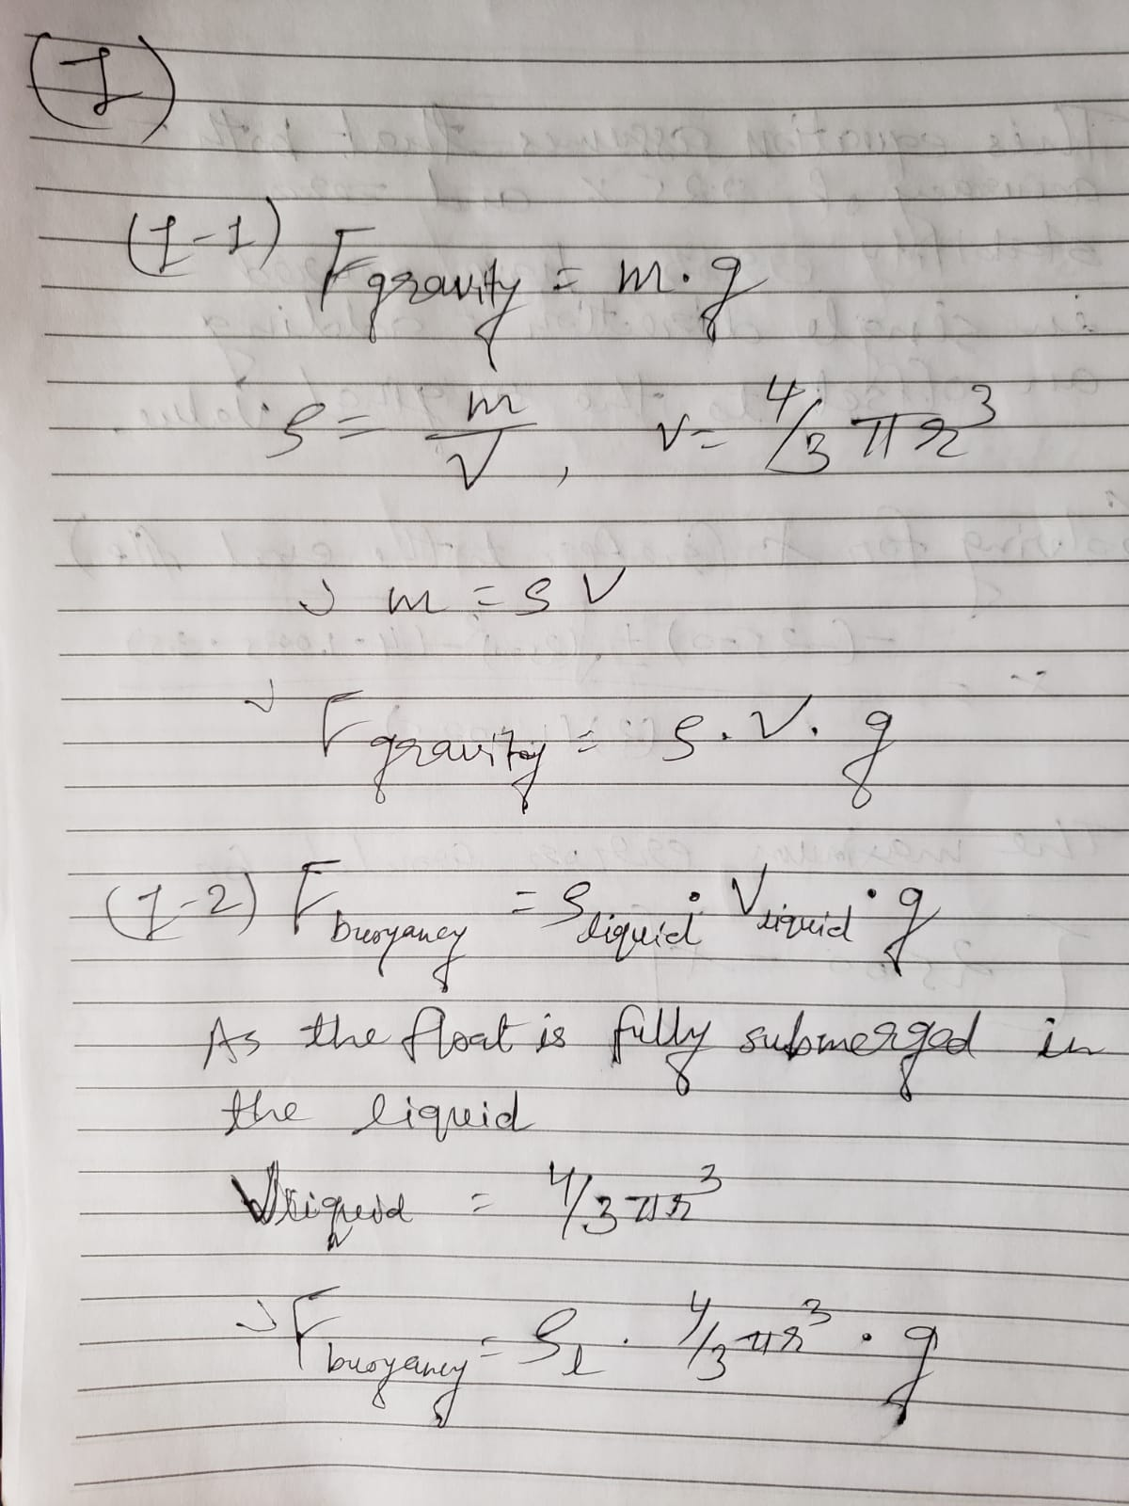 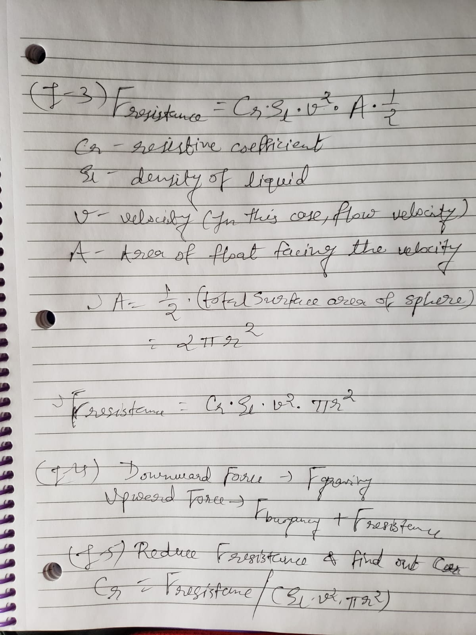 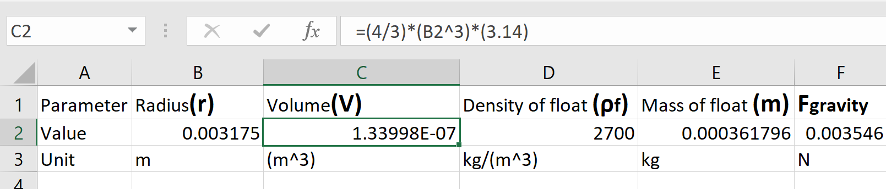 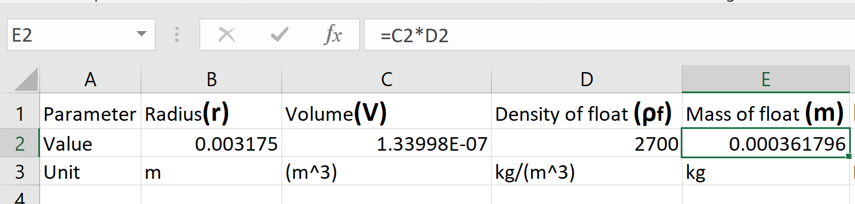 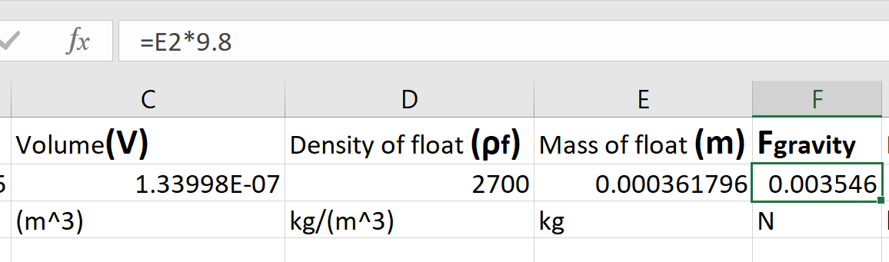 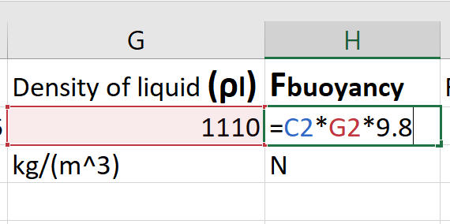 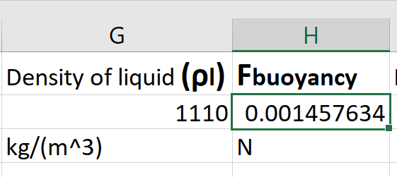 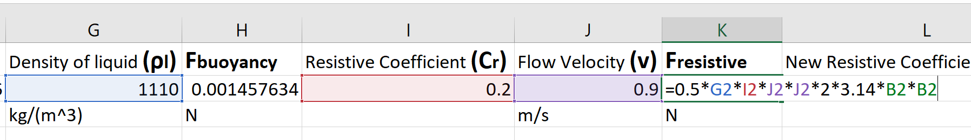 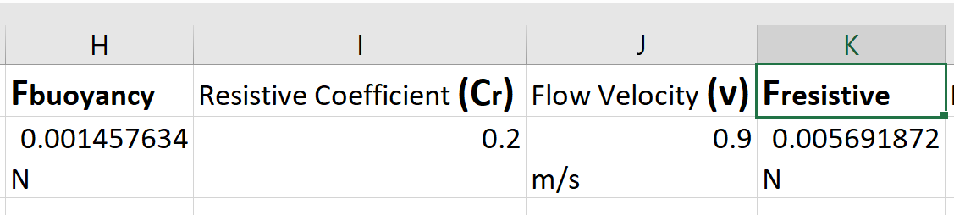 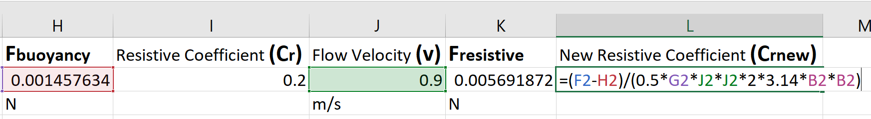 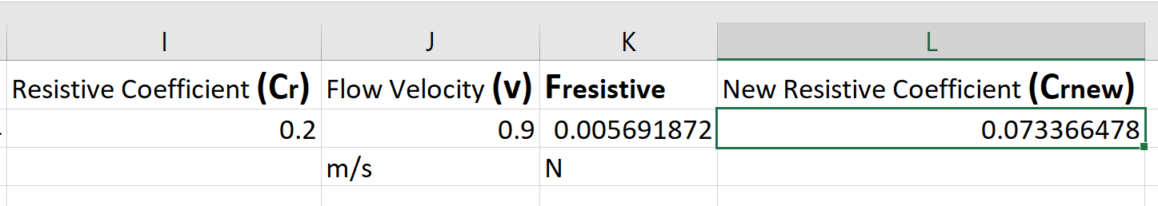

**Problem J**:What are the major advantages of the coriolis flow meter relative to the other 6 flow meters we studied in this chapter? How does this advantage show up in the types of fluids it is used to measure? What is one disadvantage of the coriolis meter?

Solution:

* Advantages: Coriolis flow meter has many advantages over other flow meters. The key advantages are – very high accuracy, no need of cutting through a pipe to install, can handle various tough situations such as flow meters for sanitary application, application where straight pipes are not there, etc., superb performance for really small pipes – which is generally not the case for other flow meters, high reliability, newer development is ongoing and constantly being improved, independent of flow profile, flow turbulence, and the density, no need to routine maintenance [**[29]**](http://www.flowresearch.com/articles/PDF_Files/FC-0811-Jesse.pdf)[**[30]**](http://www.metern.net/blog-metern-in-the-flow/coriolis-mass-flow-meter-advantages-and-disadvantages-8.html).
* Based on these advantages, a Coriolis flow meter can be used to measure the flow of a wide variety of liquids / gases. Due to no direct contact between flow meter and the liquid/gas flowing through the pipe, it can measure the flow of highly corrosive fluids. It can also be used to measure very fast flowing liquids since its measurement is independent from turbulence. Many flow meters struggle to work with sanitary application, but Coriolis flow meter can work very well with the same. In some industries where small flows of specific fluids are required, but with really high accuracy, Coriolis flow meter comes in handy as it works the best with smaller pipes, by the nature of its operation itself.
* Disadvantages: Using the same references as advantages, it is clear that the Coriolis flow meters are quite expensive, increasing the total budget of an industry wanting to implement a number of them. Also, they are not the best performers when it comes to really large pipes and flows. Apart from them, at times, it could be difficult to measure the flow of gases with very low densities.